1. **CUSTOMIZED OFFICE WORSTATION WITH FILE DRAWERS COMPUTER CUBICLES.**

low office partition / cubicles / workstation fabric with glass(stripe frosted sticker) wooden mobile pedestal , CPU rack & keyboard tray customize colors panel thickness : Bullet Series / 3.2cm Php 35,200.30 DELIVERY AND INSTALLATION INCLUDED (METRO MANILA) ***CHAIRS AND OTHER ACCESSORIES NOT INCLUDED This system can be in many different configuration. Prices are inclusive of VAT

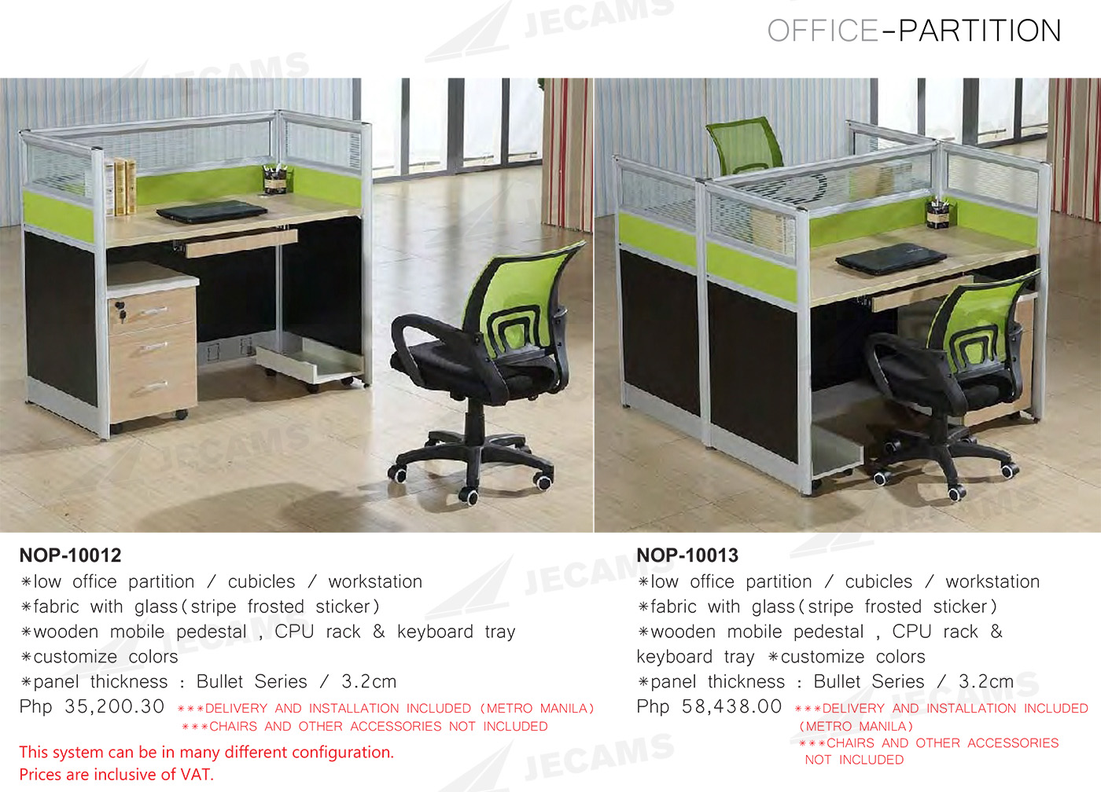

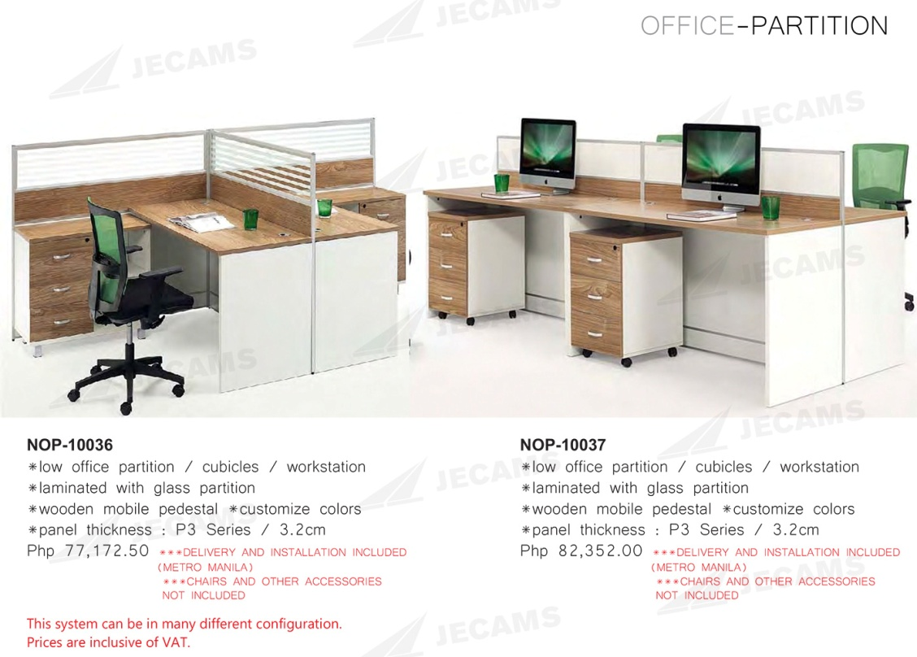

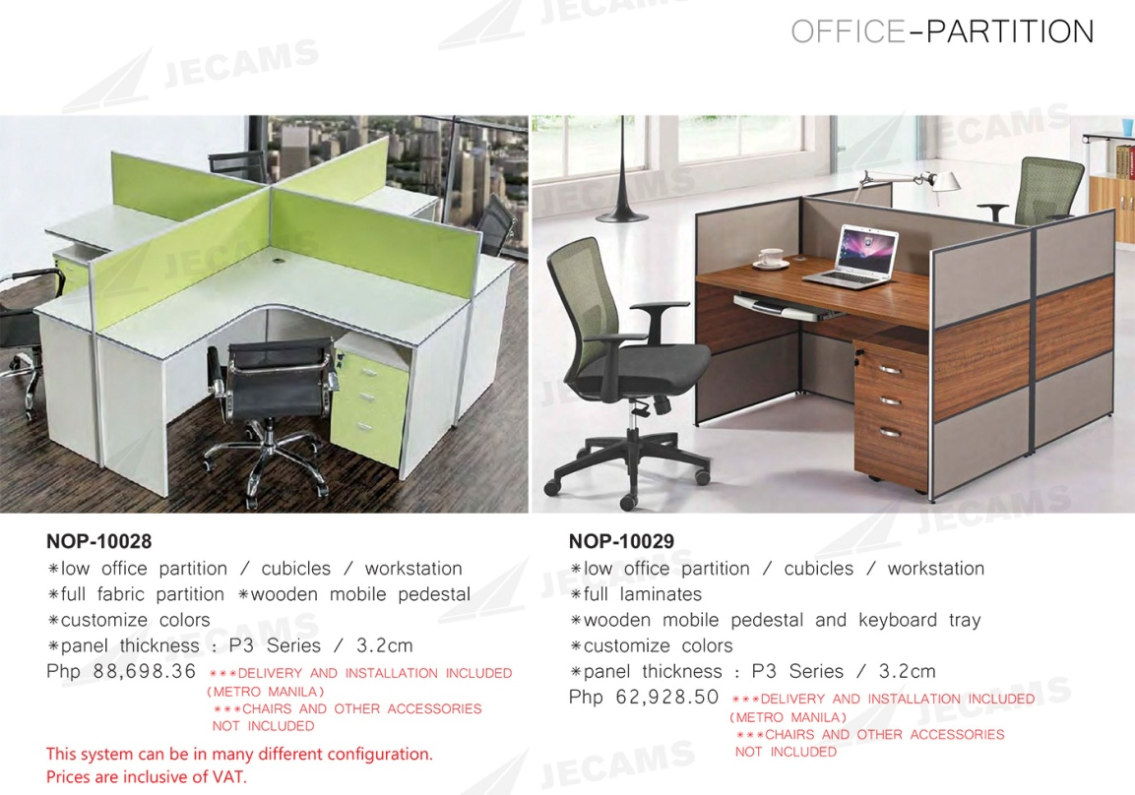

We the Sourav Fashion Collection provide total office interior design and decoration in Dhaka Bangladesh, Having 08 years’ experience in office decoration and office furniture.Get latest 2015 office workstation furniture and utilize your office space. See our office workstation and order now, we will deliver you as your requirement.   
  
Product Description  
  
Wooden Office Table Workstation with Partition, We are manufacture Office Table, Office Workstation, Partition, Office Partition, Office Furniture etc.  
  
  
01   
•••WORK STATION PARTITION : Height 4'-0" made of 2" thick KAI Aluminum Modular section, Aluminum color Approved by authority , Fabrics: Approved by authority, (as per layout)  
  
02   
•••WORKSTATION TABLE TOP : made with 25mm thick melamine board (Approved by authority), with 2mm edging and necessary hardware materials like leg pin, cable hole cap, 3 in 1 screw etc. all complete as per design.-(as per layout)  
  
03  
•••Mobile Drawer Unit :(H 26" x L 16" x D 16") with 18mm melamine board & 1mm edge pasting, structure of foreign origin brand of good quality, imported lock etc. (Locally assembled with imported foreign materials)  
  
SPECIFICATIONS:  
• Material: High quality melamine, scratch-resistant, durable  
• Board: Fireproofing, scratch-resistant, without contaminated  
• Edge: High quality PVC, smooth, fastness and durable  
• Screen Material: Aluminum frame with melamine board)  
(CUSTOMIZED COLORS, MATERIALS AND DIMENSION)  
  
• If you want we can customize the size and Design  
  
•••> P r i c e : 260 Tk/SFT  
  
According to your Dream & Imagination……  
  
All kinds of interior decoration for, Office, Market, Show room ,  
  
resturent & Hospital & clinicall kinds of interior furniture supplier&

COMPANY NAME : JECAMS COMPANY.

More details.

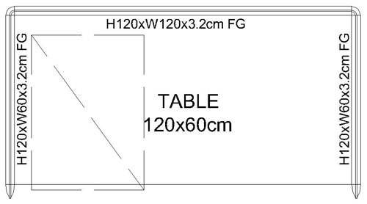

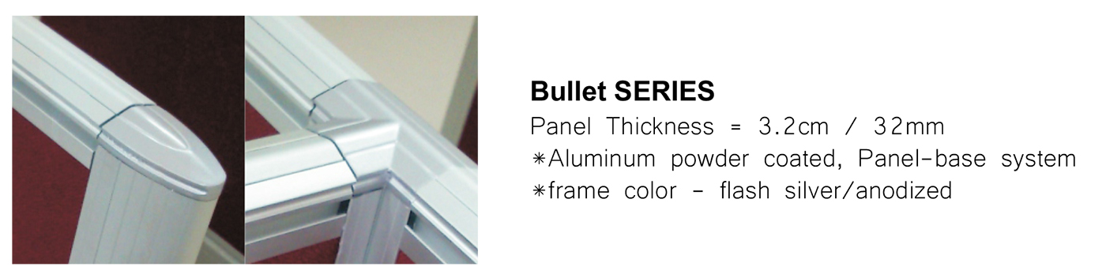

FOB Price : US $100 / piece

Min order : 5 pieces

Port : yiwu

Payment terms : Alipay, moneygram, wechat money..

Phone number : 13175508115

Email : [wyc@gmail.com](mailto:wyc@gmail.com)

We are advertizers of this company and in the case of advertizing we get paid by the number of purchased items. The more customers buy the more commission we get.

1. **DECENT LUXURY CABINETS FOR KITCHEN WITH PARTICLE BOARD.**

# Modern Simple Wood Modular Kitchen Cabinet Indoor Furniture

[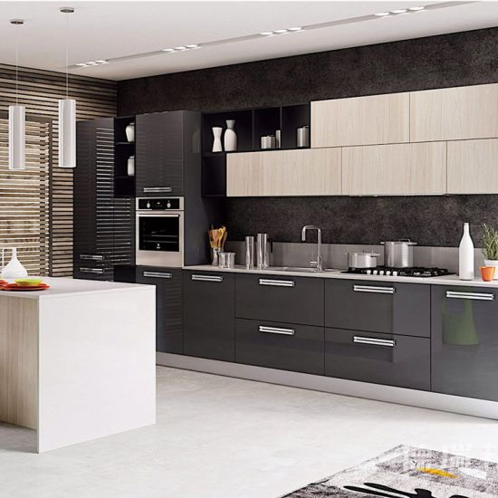](https://nanjing-shuangpeng.en.made-in-china.com/productimage/wCsJEbmxORWT-2f1j00zajYnfISORoL/China-Modern-Simple-Wood-Modular-Kitchen-Cabinet-Indoor-Furniture.html)

|  |  |  |
| --- | --- | --- |
| **Purchase Qty. / Reference FOB Price** | | |
| 1-9 Sets | | **US $2,000** |
| 10-19 Sets | | **US $1,800** |
| 20-99 Sets | | **US $1,600** |
| 100+ Sets | | **US $1,200** |
| **Port:** | Shanghai, China | | |
| **Production Capacity:** | 500, 000 Set/Year | | |
| **Payment Terms:** | L/C, T/T | | |

|  |  |
| --- | --- |
| **Feature:** | Modern |
| **Carcase Material:** | Plywood |
| **Door Material:** | MDF |
| **Table Material:** | Quartz Stone |
| **Drawer Guide Rail Kind:** | Path Rail |
| **Style:** | Island Style |
| Basic Info Model NO.: DRB-K1  Fixed: Fixed  Color: White  Certification: TUV  Customized: Customized  Condition: New  Specification.: E1 Eco-Friendly Materials Standard  OEM: Yes  Trademark: Deribon  Transport Package: Paper Box with Plywood  Specification: Customized  Origin: China Nanjing  HS Code: 9403400090 Product Description **1. Kitchen cabinet manufacturer with 10 years experience  2. Lacquer kitchen, high glossy UV/acrylic  kitchen cabinet 3. Standard sizes or Customized 4. Ready assembled**   **Modern Kitchen Cabinet Furniture  :**  **Specification :**   |  |  | | --- | --- | | **Carcase Material** | 18mm Melamine-faced chipboard  or  Plywood  or Solid Wood | | **Door Base Material** | 18mm MDF, Plywood, Solid Wood | | **Edge Banding** | PVC | | **Colors** | Customized | | **Door Surface Material** | Melamine face board / Lacquer /Acrylic door / UV high glossy   / UV color painting panel/ PVC vacuum panel | | **Countertop** | Quartz stone | | **Price** | We have standard price , also you can send us the drawing for customized price |   Modern Simple Wood Modular Kitchen Cabinet Indoor Furniture  Modern Simple Wood Modular Kitchen Cabinet Indoor Furniture Modern Simple Wood Modular Kitchen Cabinet Indoor Furniture  Modern Simple Wood Modular Kitchen Cabinet Indoor Furniture Modern Simple Wood Modular Kitchen Cabinet Indoor FurnitureModern Simple Wood Modular Kitchen Cabinet Indoor Furniture |  |
|  |  |
| **C:\Users\Ricil Maku\Desktop\Capture.PNG** |  |
|  |  |

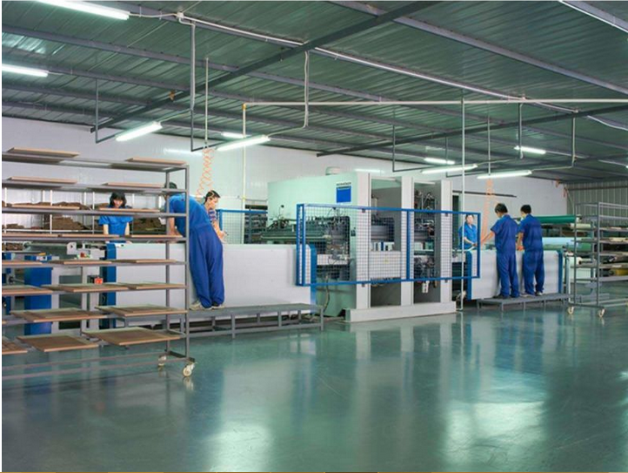

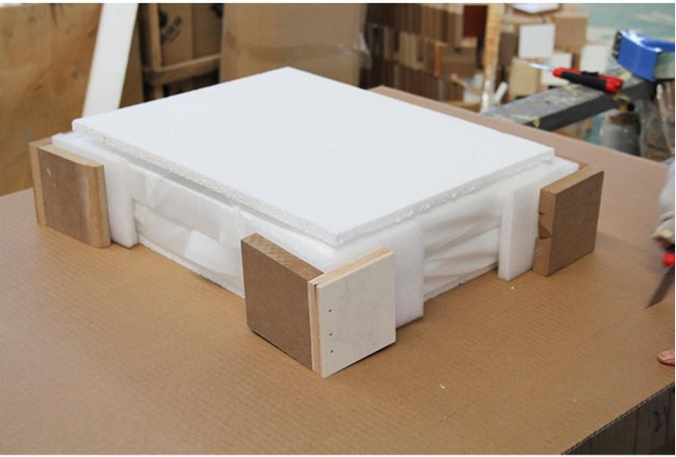

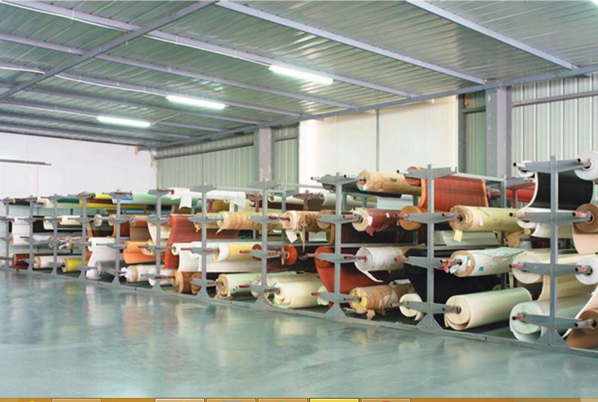

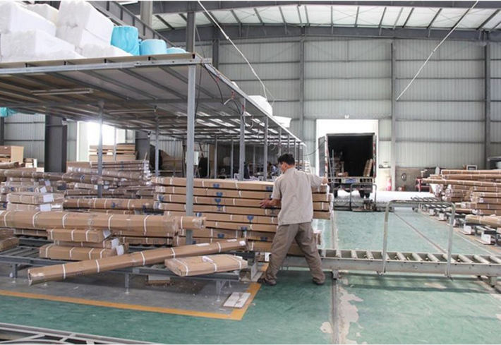

*\**From



To

Nanjing Shuangpeng Cupboard Co., Ltd.

* [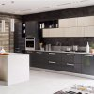](https://nanjing-shuangpeng.en.made-in-china.com/product/wCsJEbmxORWT/China-Modern-Simple-Wood-Modular-Kitchen-Cabinet-Indoor-Furniture.html)

*\**Subject



Purchase Quantity



Extra Request

Price Inspection Certificate Product Specifications Company Profile

*\**Content



# 3. contemporary modern dining set stainless steel marble top dining table luxury dining room table

# Image result for MODERN DINING ROOM FURNITURE MARBLE TOP STAINLESS STEEL DINING TABLE

Price:

US $899.00 / piece

**Whatsapp:008613906872694**

**Skype:Greenglobecandy**

**Wechat:cassieluzhu**

Email: [greengrobeli@hotmail.com](mailto:greengrobeli@hotmail.com)

Payment : moneygram, alipay, western union

Item specifics

* Type: Dining Room Furniture
* Specific Use: Dining Table
* General Use: Home Furniture
* Additional Function: Dining room
* Is Assembled: KD
* Layers: One layer
* Packing: Standard Export Pakage,Carton case+EPE+Wooden Panel
* Size: 1500*900*750mm
* Shape: Rectangle Dining table
* Metal Type: Stainless Steel
* With Stool: With 4 Chairs(Pls kindly note:Chair price is extra)
* Is Customized: Yes
* Style: Black&Modern
* Appearance: Modern
* Finishes Material: Marble surface table
* Material: Metal
* Applicable Number: 4/6/8
* Place Of Origin: CHINA
* With Rollers: no
* Pattern: No Patterns
* Folded: No
* Model Number: M-6312
* **Price is negotiable accordding to the quality.**
* **Fabric color and size are customized.**
* **We are very profesional and trustable.**
* **We cannot wait to hear from you**

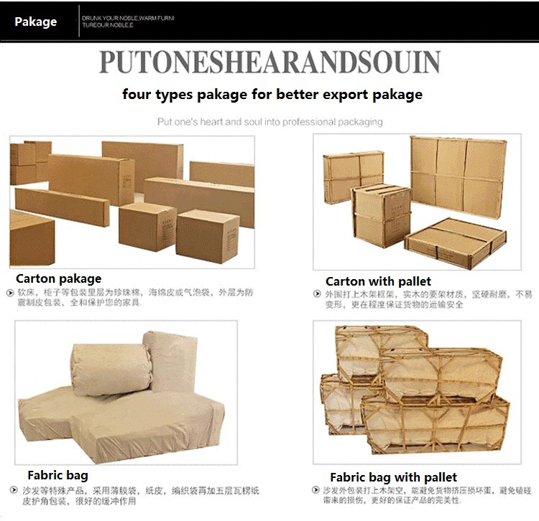

# 4. boss table HX-G0195 office wooden MDF executive desk manager table furniture office 2016 China manufacturer hot sale

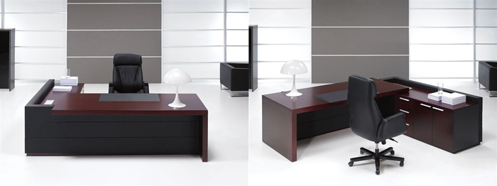

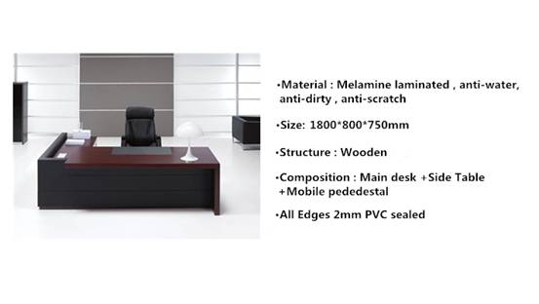

More Pictures Of HX-G0195:



Address:Beisha industrial zone, Yangjiao, Lecong Town, Shunde District, Foshan City, Guangdong Province, China  
Tel:+86-757-28782125  
Fax:86-757-28782135  
E-mail:[manager@hx-f.com](mailto:manager@hx-f.com)

FOB: US $500

Min order: 15-23

Payment terms: L/C, TT, WESTERN UION

Executive Office Desk color selection:more than 30 colors available

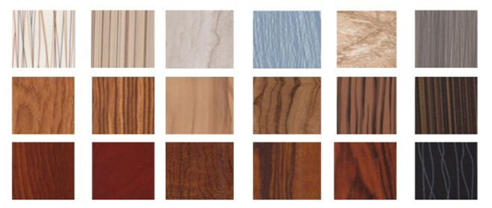

Heng Xing Office Furniture Limited main products: office table, office desk, computer desk,   
conference table, reception table, office partition, file cabinet, bookshelf,   
various kinds office chairs and related office furniture project products.

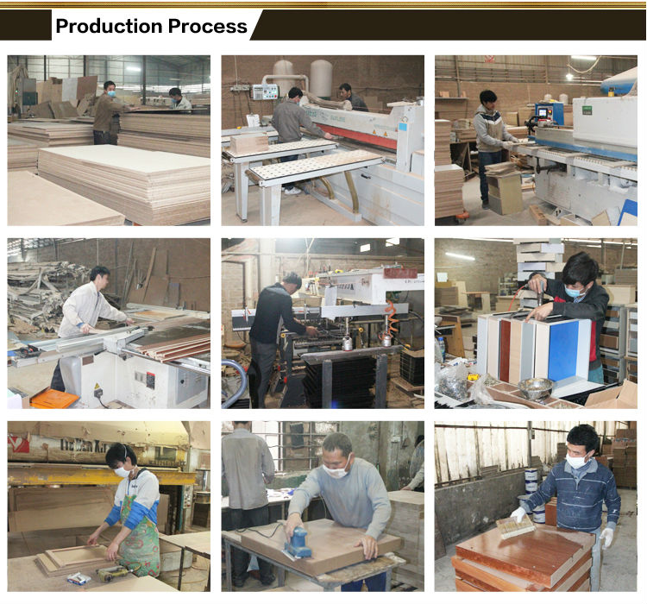

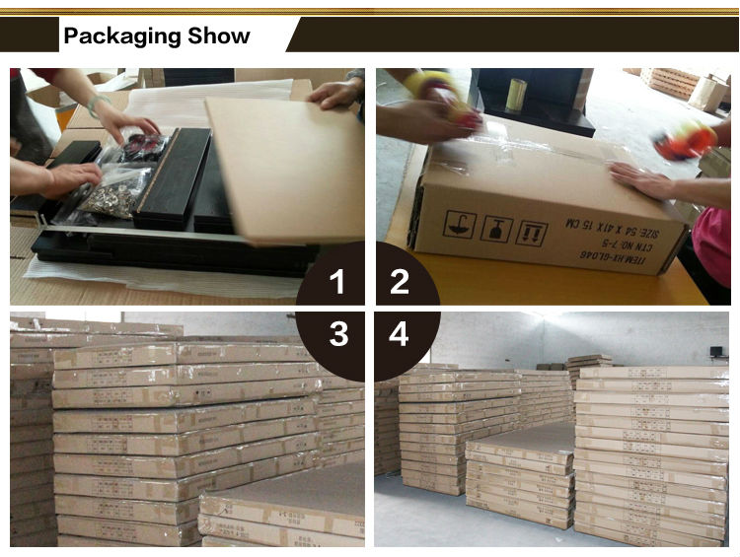

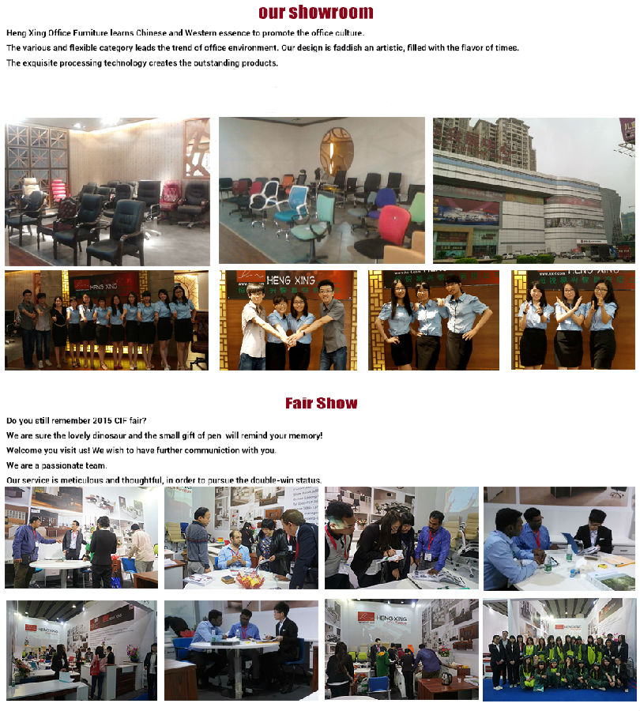

# 5. Classic Bedroom Furniture Set with Classic Bed (6618)

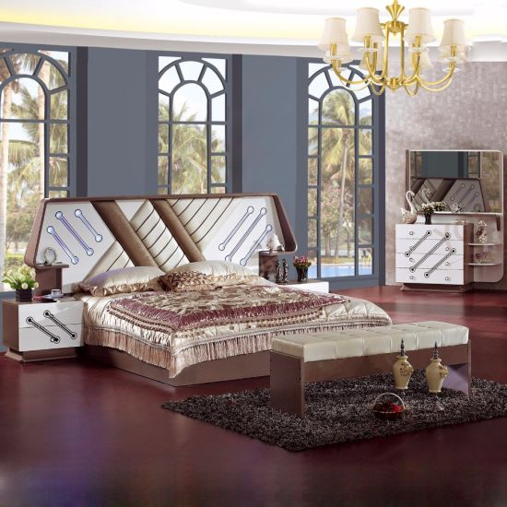

## Product Description

Foshan Shunde YiFan Furniture Co., Ltd, located in Furniture center of Foshan City of Guangdong Province, is specially in manufacturing Sofa, Bedroom Furniture, Living Room Furniture, Home Furniture and Wood Furniture, which is a private enterprise with numerous eligible proficient craftsmen, advanced equipments and sophisticated administrators  
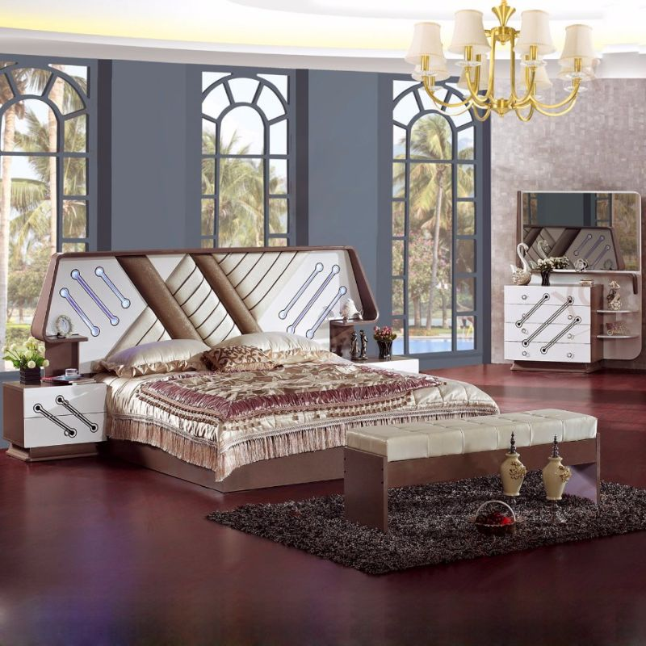  
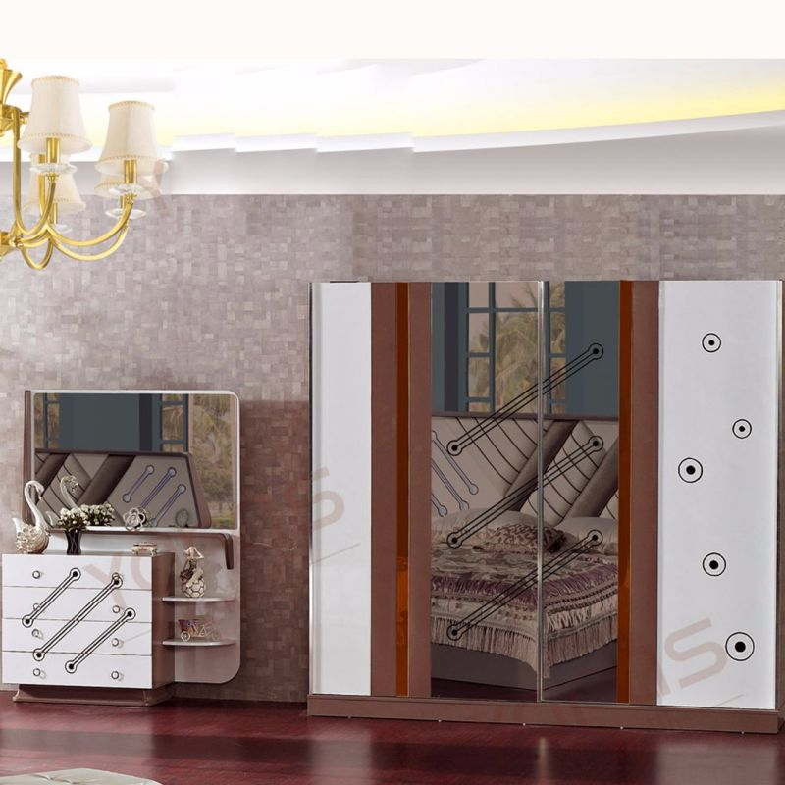  
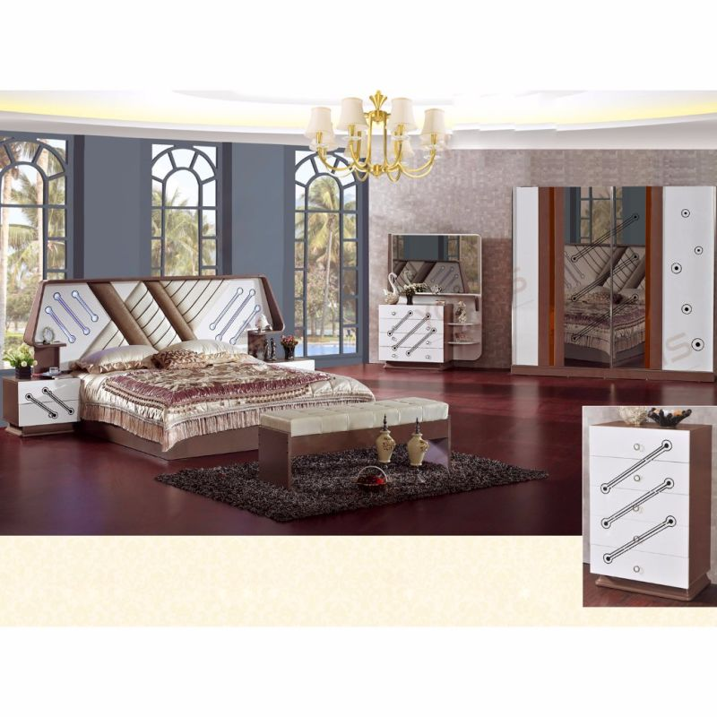

## Basic Info

Model NO.: YF-6618

Disassembly: Disassembly

Height Adjustable: Unadjustable

Shape: Square

Color: Red

Customized: Non-Customized

Washable: Washable

Condition: New

Top Coat: Sealed PU Paint

Primary Coat: PU Paint

Mixed Container Order: Accepted

Cleaning: No Water Washable (Directly)

Cubic: 1.8

Stock: No

Warning: Avoid Direct Sunshine

Mixed Model: Accepted

Shipping Service: Accepted

LCL Order: Accepted

Trademark: Star Home

Transport Package: Knock Down

Specification: European

Origin: China

HS Code: 940359000

Min order: 17 sets

Port: Guangzhou, china

Payment terms: TT, western union, Moneygram

Production capacity: 900 sets/months

Size : double

Style: antique

Phone number: 18725568447

Email: [forshancompany@yahoo.com](mailto:forshancompany@yahoo.com)

Factory: **Foshan Shunde YiFan Furniture Co., Ltd.**

NAME OF SUPPLIER: Mr. Darell.

**Package:** Knock Down  
  
**Transportation Way:** Sea Transportation and International Multiple Ways  
  
**Place of Receipt:** In Factory or Customer Appointed  
  
**Port of Loading:** Shenzhen Port or Customer Appointed  
  
**Shipping Transportation:** Client Appointed or Factory Arrangement  
  
**Payment Term:**T/T, Western Union, Money Gram  
  
**Produce Time:** Within 35 Days in Peak Seasons and 23 Days in Normal Seasons  
  
**Loading Container:** 30% Deposit and Payment Balance before Delivery

|  |  |  |  |
| --- | --- | --- | --- |
| Trade Term | Place of Receipt | Loading of Port | Shipping Cost |
| EXW | In Factory or All Places of China |  | Buyer |
| FOB | In Factory or All Places of China | Shenzhen Por or Customer Appointed | Buyer |
| CFR | In Factory or All Places of China | Shenzhen Por or Customer Appointed | Factory |
| CIF | In Factory or All Places of China | Shenzhen Por or Customer Appointed | Factory |
|  | | | |
| Type of Container | | Container' s Accomodation | |
| 20' GP Container / 20' Feet General Purpose Container | | 17 Sets Per 20' GP Container | |
| 40' GP Container / 40' Feet Dry Freight Container | | 33 Sets Per 40' GP Container | |
| 40' HC Container / 40' Feet High Cube Dry Container | | 43 Sets Per 40' HQ Container | |
|  | | | |
| Model | Item | Size (millimeter) | Quantity (piece) |
| YF-6618 | Classical Bed | 2630*2080*1290 | 1 |
| YF-6618 | Night Stands | 560*415*470 | 2 |
| YF-6618 | Wardrobe | 2400*605*2200 | 1 |
| YF-6618 | Dresser Table | 1220*465*1660 | 1 |
| YF-6618 | Five Drawers Chest | 700*400*1080 | 1 |

